[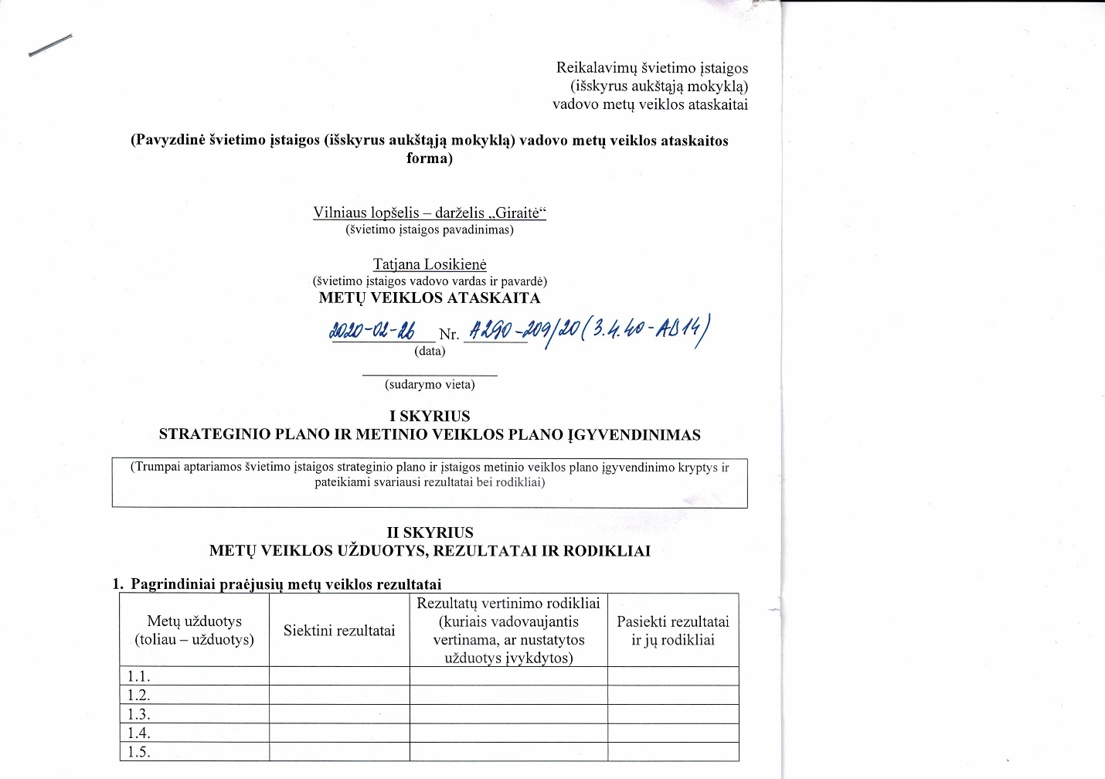](http://www.giraite.vilnius.lm.lt/wp-content/uploads/2015/06/CCI_000039.jpg)

[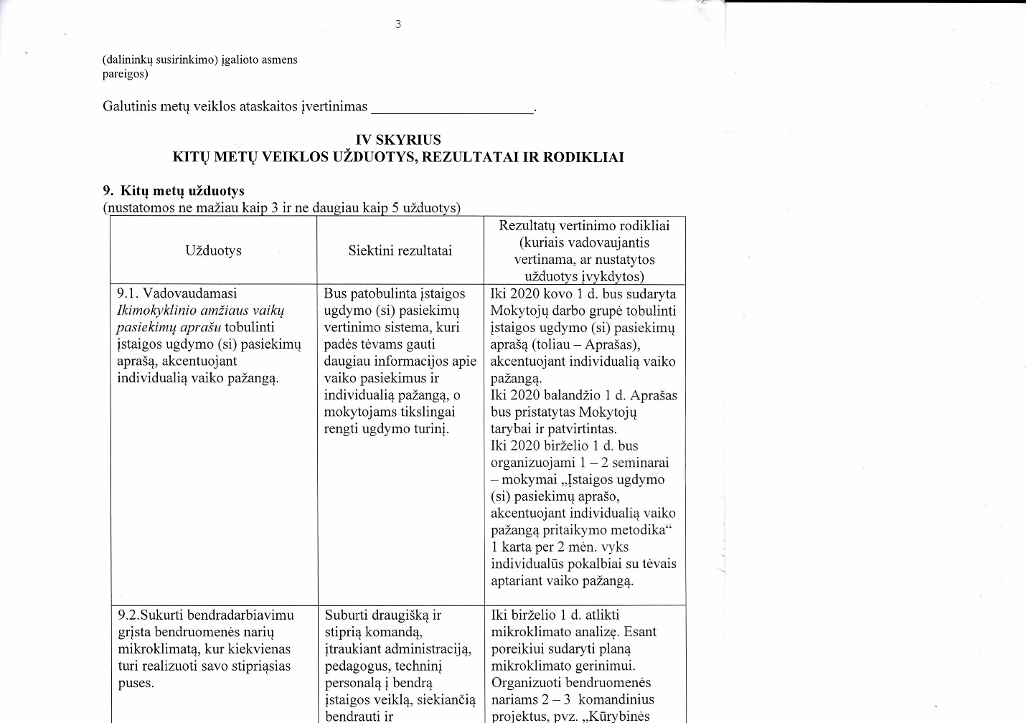](http://www.giraite.vilnius.lm.lt/wp-content/uploads/2015/06/CCI_000040.jpg)

[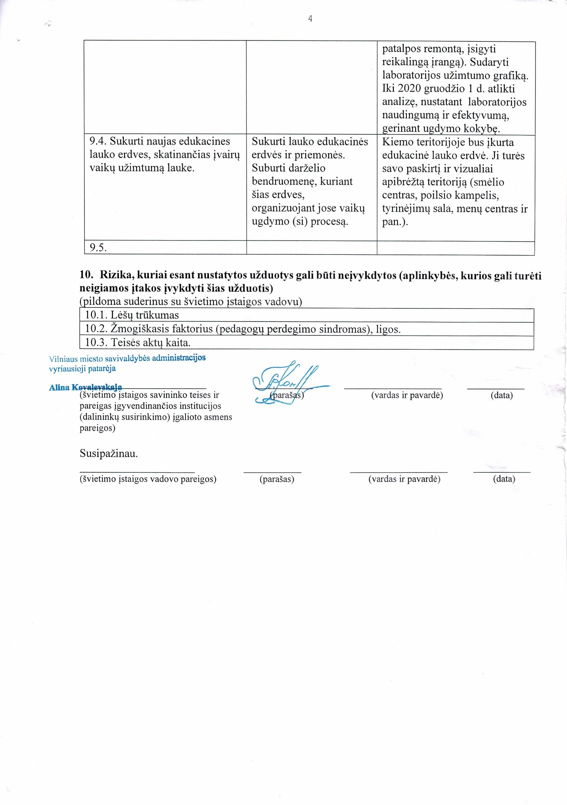](http://www.giraite.vilnius.lm.lt/wp-content/uploads/2015/06/CCI_000041.jpg)